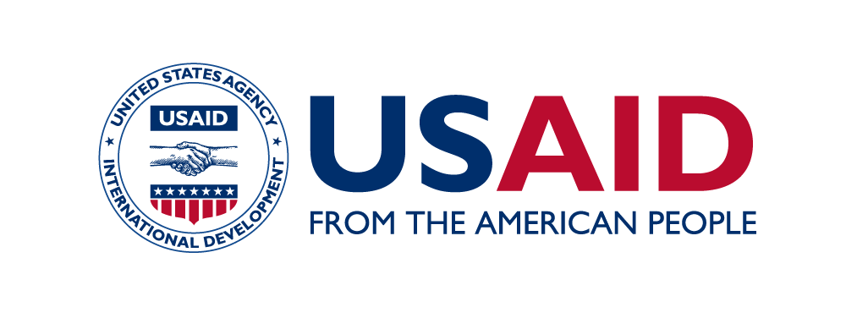
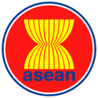

Underwriters Laboratories-ASEAN-U.S. Science Prize for Women 2023

Official Prize Rules

Date of Issuance | : | 8 February 2023
Closing Date | : | 14 April 2023
Notification of National Finalists | : | 21 June 2023
Estimated Notification of Regional Finalists | : | 21 September 2023
Estimated Head-to-Head Pitch Competition | : | October 2023
Estimated Notification of Winner and Awards Ceremony | : | October 2023

Introduction

Through the Underwriters Laboratories-ASEAN-U.S. Science Prize for Women (“Prize”), the United States Government, in partnership with the Association of Southeast Asian Nations (ASEAN) and Underwriters Laboratories, aims to provide promising female scientists, of ASEAN nationality, the opportunity to showcase their innovations that can help address real life challenges in sustainable ways. It is also hoped that through the Prize, female role models can serve to encourage more females to embark in science, technology and innovation activities.

Eligibility

In order to participate in this Prize, applicants must meet all of the following criteria. An applicant must be a/an:
- Female professional working in applied science
- Citizen of an ASEAN Member State
- ASEAN Member States (AMS) include: Brunei Darussalam, Cambodia, Indonesia, Lao PDR, Malaysia, Myanmar, Philippines, Singapore, Thailand, and Viet Nam.
- Holder of a PhD or equivalent doctoral degree. Applicants who are a candidate for, or in process of pursuing a PhD or doctoral degree are not eligible.
- To qualify for the Mid-career Scientist category, the applicant must be 45 years or below at the time of the close of the application period.
- To qualify for the Senior Scientist category, the applicant must be aged 46 or older at the time of the close of the application period.
- Academician / researcher / innovator / technologist / expert / practitioner working on topics related to the theme of “Electrification.”

Prize Theme

The Theme for the 2023 Prize is “Electrification.” The applicants will have to demonstrate not only a strong understanding of topics related to the theme, but also specifically how their research and innovations impact the community. They must demonstrate how their work targets one or more of the following goals:
- Develop electrification technology that promotes the use of electrical power and therefore combat climate change;
- Develop methods that replace use of fossil fuels (coal, oil, and natural gas) with technologies that use electricity a source of energy which helps reduce emission of carbon dioxide (CO₂) from transportation, building, industrial and other sectors;
- Apply electrification technology and innovations in reducing the use of fossil fuels to help decarbonize the economy and mitigate the impacts of climate change;
- Assist communities to utilize renewable energy, which provides electricity access for all and reduce electricity costs for consumers;
- Inspire and motivate other women scientists and researchers to work on this topic or other relevant STEM topics.

The Prize

The Prize has two categories – Mid-career scientists and Senior scientists. Both winners of the Mid-career category and the Senior category will receive a cash prize of USD 12,500. The honorable mention in each category will also receive a cash prize of USD 5,000. Separate provisions will be made to cover the travel, food, and lodging expenses for the two Regional Finalists of each category to attend a pitch competition cum award ceremony before the representatives of the Underwriters Laboratories, USAID, ASEAN COSTI, and ASEAN Secretariat. The prize money is sponsored by Underwriters Laboratories.

Application Requirements

In order to be considered for the Prize, regardless of the category, applications received by the deadline must include all of the following:
- A completed application form with all fields and questions filled up. Applications with questions unanswered will be disqualified.
- A Curriculum Vitae (CV)
- A letter of recommendation submitted by an academic or professional contact
- A letter of support submitted by a female mentee or other women who have been impacted by the applicant

Documents 1 and 2 are to be submitted online at www.scienceprize4women.asean.org. The application form can be downloaded from that website. There is no preferred form for the CV.
Documents 3 and 4 are to be emailed directly to scienceprize4women@gmail.com by the referees with file name and subject line: Letter of Recommendation for [candidate’s name and country of origin].

All four documents (application form, CV and two letter of recommendations) must be received by the Prize administrators before the application submission deadline for an application to be considered. If you are having trouble with your form or having questions on application submission, please contact scienceprize4women@gmail.com.

Important Dates

- Deadline of submission 11:59 pm GMT+7 on 14 April 2023
- Estimated Announcement of National Finalist 21 June 2023
- Estimated Announcement of two Regional Finalists 21 September 2023
- Estimated Head-to-head Pitch Competition October 2023
- Estimated Notification of Award ceremony October 2023

Review Process

Review process for the two categories consists of four stages which are set below.
Stage 1 – Screening for eligibility
Stage 2 – Selection of the National Finalists for each category
Stage 3 – Selection of the two Regional Finalists for each category
Stage 4 – Selection of winner for each category

Stage 1 – Eligibility review – Once the application window has closed, the Prize administrators will review each application to verify that it is complete, and that the application meets the criteria as set out in Section V Application Requirements. Applications that do not meet the criteria will be automatically disqualified.
The pool of eligible applicants will proceed on to Stage 2.
Stage 2 – Selection of the National Finalists for each category – One Mid-career Scientist and one Senior Scientist from each AMS.
Each ASEAN Member State will assess all eligible applications for each category from their respective state and select one National Finalist for each category using the evaluation criteria as set out below. The decision of the ASEAN Member State is final.
The Prize administrator will notify each national finalist of her status by Mid of April 2021. Upon receiving word of her selection, each National Finalist will be asked to submit a video (no more than 3 minutes) for the next stage of the judging process. Details of the content of the video will be included in the notification. All National Finalists will have two weeks from the time of notice to submit their videos. These videos will be broadcast through YouTube and social media to highlight the work of each of the twenty National Finalists.
Stage 3 – Selection of two Regional Finalists for each category.
The panel which includes representatives from the Underwriters Laboratories, USAID, and the ASEAN Secretariat will review and score the national finalists. Two Regional Finalists from each category will be selected based on the highest and second highest scores. The names of the Regional Finalists will be officially announced through the Prize’s website and social media outlets.
The two Regional Finalists for each category will be asked to prepare an abstract of their research, a resume, and a presentation to be used in Stage 4.
Stage 4 – Selection of Winner for each category.
This will be done via a pitch competition at a platform determined by the Prize administrators. The judging panel will consist of representatives from Underwriters Laboratories, national COSTI chairs of each ASEAN Member State, USAID, and the ASEAN Secretariat.
Each Regional Finalist will be requested to present a 3-minute video, 5-minute presentation and engage in a 5-minute question and answer session with the judging panel. The judging panel will vote for the winner in each category of the competition.
The finalist who receives the most votes will be named the winner while the other finalist will be conferred the honorable mention.

Evaluation Criteria

The evaluation criteria and scoring for the Science Prize are set out below. It is a total of 100 points.
Scientific Excellence (50 pts)
- Applicant clearly outlines her research that is relevant to the topic, and demonstrates not only a strong understanding of the scientific subject topic, but specifically how her research, technology or business model relates to the Prize topic. (20 pts)
- Applicant provides examples of relevant and impactful awards or merits for her work. Higher scores will be reserved for well-established awards. (10 pts)
- Applicant’s work appears to be highly regarded by peers. Think about: Has she been featured in media placements, policy briefs, or academic journals? Does her work suggest that she is an influencer in the field? (10 pts)
- Applicant outlines clear areas for growth potential in her career. Applicant demonstrates excitement, passion, and motivation for her field of work. Higher scores will be reserved for applicants who specifically demonstrate how they’d like to continue to improve in the topic of the year. (10 pts)

Mentoring, inspiring, and supporting women and up-and-coming female members of the STEM community (25 pts)
  - Applicant shows a clear level of involvement in mentoring, supporting and/or empowering female students, colleagues or other women in STEM. Applicant provides specific examples when possible and demonstrates passion and drive to create a gender-inclusive STEM environment. (10 pts)
  - Applicant clearly demonstrates how her work accounts for gender in the subject topic area. She explains how her work specifically enables women to be change agents in the topic area. (9 pts)
  - Applicant provides examples of how she strives to improve opportunities for women in STEM. Applicant should note any involvement in/with or membership in organizations focused on gender inclusivity. Applicant provides details about the organization and her unique role/contribution. (6 pts)

Global Citizen (25 pts)
- Applicant shows a strong connection between her work and improving the implementation of topic of the year in ASEAN as a region. Applicant demonstrates how she uses science, technology and innovation to achieve these goals. (10 pts)
- Applicant demonstrates an active role in scientific collaboration with scientists/scientific communities of practice across ASEAN to improve the regional value chain as a whole. Higher points will be awarded to applicants who provide concrete examples of collaboration. (9 pts)
- Applicant shows how her work impacts her local community, country and the greater ASEAN region. Applicant provides examples where possible. Applicant sees larger role for her work across the greater ASEAN region and the world. (6 pts)

Publicity Consent

By submitting an entry application or accepting a prize, each candidate grants to USAID, the U.S. Mission to ASEAN, ASEAN, Underwriters Laboratories, and USAID-IGNITE the irrevocable right without any further notice, review or consent to print, publish, broadcast, distribute, and use, worldwide in any media now known or hereafter developed including, but not limited to, the World Wide Web, in perpetuity and throughout the universe, including without limitation, the entry and candidate’s name, portrait, picture, voice, likeness, image or statement about the contest, and biographical information as news or publicity or information and for trade, advertising, public relations and promotional purposes without any further compensation, that are related to or pertaining to the 2021 Underwriters Laboratories-ASEAN-U.S. Science Prize for Women.

Disclaimers

- The prize administrators may cancel the solicitation and not issue an award
- The prize administrators may reject any or all responses received
- Issuance of solicitation does not constitute an award commitment
- The prize administrators reserve the right to disqualify any application based on candidate’s failure to follow solicitation instructions
- The prize administrators will not compensate applicants for their applications
- The prize administrators reserve the right to issue awards based on initial evaluation of applications without further discussion

